Gösta's Pavilion, Kaisa House, the Museum of the History of Polish Jews, and Seinäjoki main library Apila shortlisted for the Finlandia Prize for Architecture

Professor Sixten Korkman to select the winner of the prize

Autumn 2014 will see the Finnish Association of Architects, SAFA, award the new Finlandia Prize for Architecture for the first time. The four shortlisted candidates for the prize, three of which are located in Finland and one in Poland, are the Serlachius Museum's Gösta's Pavilion in Mänttä; Kaisa House, the main library of the University of Helsinki; the Museum of the History of Polish Jews in Warsaw; and Seinäjoki main library Apila. The winner of the prize will be selected by Sixten Korkman, Professor of Practice in Economics at the Aalto University. The winner will be announced at an event to be held in November.

Everyone can be an architecture expert

The organisers wanted the judge chosen for the competition to be an influential figure who is known as an expert in a field other than architecture. The selection seeks to emphasise the fact that high-quality architecture is, at its best, an experience that resonates with all its users. Everyone can be an architecture expert.

"When I look at the designs of architects, I pay attention to at least three points. What is the relationship between the formal idiom of the building and its use? How well does the design combine aesthetics and function? How does the building 'sit' in its environment? High-quality architecture is important, because the built environment is our extended living room and affects how at home we all feel. As a sixth-former, I dreamed of becoming an architect, but I realised that I did not have enough artistic talent for it, and decided to go for other career choices," Professor Sixten Korkman says of his view of architecture.

The prize is awarded to a design or renovation design for an outstanding new building or building complex that has been completed within the past three years. The selected candidates represent high-quality public architecture. This time, no residential projects were included among the shortlisted candidates.

"Public construction is currently offering more opportunities to realise fresh ideas than residential projects. In Finland, residential architecture has, for a long time, been in a state of stagnation. All the shortlisted candidates were winners of an architectural competition, and the designers of the buildings represent three generations. I'm happy to see that our architecture is being transformed, while the tradition of expertise continues," says Jorma Mukala, chairman of the pre-selection jury, architect, and editor-in-chief of the Finnish Architectural Review.

The other members of the pre-selection jury are the director of the Museum of Finnish Architecture Juulia Kauste, the architect Esa Ruskeepää, and the Professor of Spatial Design at Aalto University, School of Arts, Design and Architecture Pentti Kareoja. The secretary of the jury is the SAFA secretary general Paula Huotelin.

Shortlisted candidates represent high-quality public architecture

Gösta's Pavilion, completed in Mänttä in the summer of 2014, is an extension to the Serlachius museum Gösta. The art museum was designed by the Spanish architectural studio MX_SI, with Huttunen-Lipasti-Pakkanen Architects acting as a collaborator in the implementation stage. According to the statement by the pre-selection jury, Gösta's Pavilion and the old museum building, the Joenniemi manor, and its garden, which opens towards the lake, combine to create a unique, memorable milieu.

Kaisa House is the main library of the University of Helsinki, housing the collections of the humanities, law, theology, and political science. The building was designed by Anttinen Oiva Architects. The library was opened to the public in September 2012, as part of the World Design Capital Helsinki 2012. According to the pre-selection jury, the library building tackles the challenging design brief superbly: it both serves as a signature building and continues the existing urban block structure.

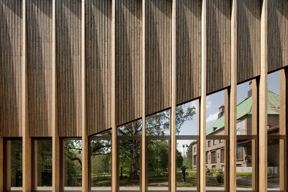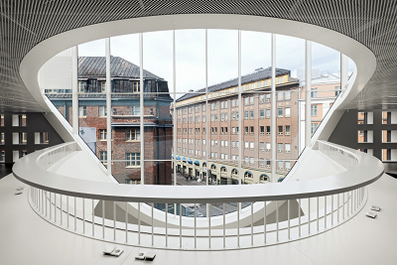
Gösta's Pavilion Kaisa House

The extension of the Seinäjoki Public Library and Provincial Library, Apila ('Clover'), was opened to the public in August 2012. The entire library consists of two buildings: Apila, designed by JKMM Architects, and the old main library, which was designed by Alvar Aalto and completed in 1965, and which will be reopened after a renovation in 2015. According to the pre-selection jury, the building’s design approach, "from the whole to the smallest detail", carries on the best of the Aalto tradition, even if the architecture consciously asserts itself as being from the 2010s.

The Museum of the History of Polish Jews in Warsaw opened its doors to the public in spring 2013. Designed by Lahdelma & Mahlamäki Architects, the museum is located in the very heart of Jewish Warsaw, which the Nazis turned into the Warsaw ghetto during the Second World War. According to the statement by the pre-selection jury, the building is a Song of Songs of Finnish excellence: the museum conveys a universal experience, regardless of ethnicity or creed.

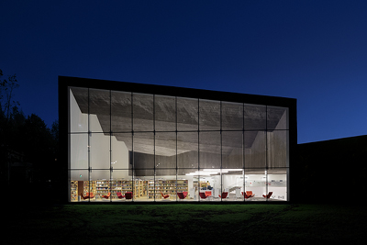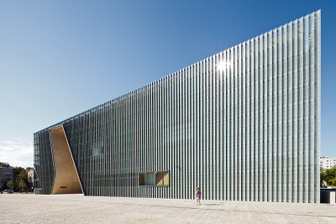
Seinäjoki Public Library Apila The Museum of the History of Polish Jews

The Finlandia Prize for Architecture is awarded to a design or renovation design for an outstanding new building or building complex. The prize may be awarded either to a Finnish or foreign architect, or to an architectural firm, for a project designed for a location in Finland; or to a Finnish architect or architectural firm for a project designed for a location abroad.

The purpose of the prize is to promote the appreciation of high-quality architecture, and to highlight the importance of architecture in producing cultural value and increasing well-being. The Finnish Association of Architects, SAFA, made the decision to establish the Finlandia Prize for Architecture on 12 December 2011. The prize logo was created by the graphic designer Aimo Katajamäki. The logo was inspired by the earlier Acanthus leaf logo, drawn for SAFA by Alvar Aalto.

The Finnish Association of Architects, SAFA, is a non-profit professional organisation that actively promotes the interests of its members, as well as architecture and high-quality living environments in general. The membership of the Finnish Association of Architects, SAFA, established in 1892, is approximately 3,100 architects with a university degree. SAFA also has some 600 student members.

Website: www.arkkitehtuurinfinlandia.fi
Facebook: www.facebook.com/ARKFinlandia
Twitter: https://twitter.com/ArkfinPrize

More information:
- Media contact: Anna Kari, Pink Eminence, tel. +358 40 717 8185, anna (at) pinkeminence.fi
- Press images: www.arkkitehtuurinfinlandia.fi
- Other information: Jorma Mukala, tel. +358 45 635 7634 or Paula Huotelin, tel. +358 9 5844 4224

